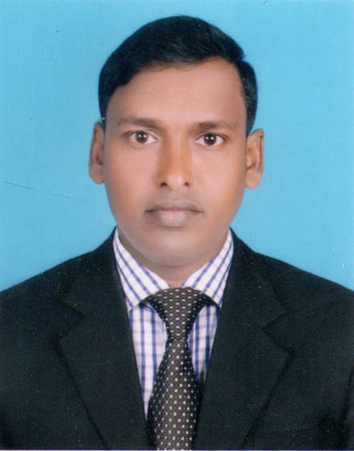
CURRICULUM VITA

OF
MD. ALAMGIR HOSSAIN
Vill : Khyra, P.O : Shadopara- 6251
P.S : Bagmara, Dist : Rajshahi
Mobile No: +88 01734545902
Email – md3139594@gmail.com

CAREER & APPLICATION INFORMATION

Career Objective:

To establish career a national or International organization with good moral objective where there is an opportunity to learn grow and flourish my knowledge, skills to lead in a way that best serve the purpose of the organization as well as the country financially and strategically.

EDUCATION QUALIFICATION

(MASTER OF BUSINESS ADMINISTRATION) M.B.A

- Name of the Institute : University of Rajshahi
- Dearptment : Management Studies
- Passing Year : 2019
- Result : 3.63 (Out of 4)
- University : University of Rajshahi

(BACHELOR OF SOCIAL SCIENCE) B.S.S Pass

- Name of the Institute : Taherpur College, Rajshahi
- Department : B.S.S
- Passing Year : 2014
- Result : 1st Class
- University : National University

HIGHER SECONDARY CERTIFICATED (H.S.C)

- Name of the Institute : Taherpur College, Rajshahi
- Group : Buiness Studies
- Passing Year : 2011
- Result : GPA 4.15 out of 5.00
- Board : BTEB

SECONDARY SCHOOL CERTIFICATED (S.S.C)

- Name of the Institute : Taherpur High School, Rajshahi
- Group : Science
- Passing Year : 2006
- Result : GPA 2.38 out of 5.00
- Board : Rajshahi

PERSONAL CAPABILITY

- Creative, Innovative and Charismatic.
- Medium in English conversation.
- Able to work under pressure and enjoy working to face the challanges.

COMPUTERS SKILLS

- MS Office, MS Excel, Power Point
- Internet Browsing, E-mailing & Software Installation.

LANGUAGE PROFICIENCY

- Excellent communication skills in English and Bengali both written and verbal.

PERSONAL INFORMATION

Name : Md. Alamgir Hossain
Father's Name : Md. Fain Uddin
Mother's Name : Zaheda Begum
Date of Birth : 11 December, 1989
Gender : Male.
Religion : Islam.
Nationality : Bangladeshi (By birth).
Marital Status : Unmarried.
Height : 5`-7``
Weight : 62 Kg
Blood Group : B+
Permanent Address : Vill : Khyra, P.O : Shadopara- 6251
P.S : Bagmara, Dist : Rajshahi

REFERENCE

Md. Saiful Islam
Professor
Department of Management Studies,
University of Rajshahi
Cell : +88 01752720789

K.M. Sabbir Hasan
Assistant Professor
Department of Management Studies,
University of Rajshahi
Cell : +88 01712040689
E-mail – sabbirhasan81@yahoo.com

DECLARATION

I am undersigned, hereby declare that at the information included here are true to my knowledge.

...............................
Md. Alamgir Hossain
Date :

